Assessment 1: SQL

QUESTION 1:

1)Write an SQL query to print all Worker details from the Worker table order by FIRST_NAME

Ascending and DEPARTMENT Descending.

SELECT *FROM worker ORDER BY first_name ASC, department DESC;

2)Write an SQL query to print details for Workers with the first names “Vipul” and “Satish”

from the Worker table.

SELECT *FROM worker WHERE first_name IN ('Vipul', 'Satish');

3)Write an SQL query to print details of the Workers whose FIRST_NAME ends with ‘h’ and

contains six alphabets.

SELECT* FROM worker WHERE first_name LIKE '______h';

4)Write an SQL query to print details of the Workers whose SALARY lies between 1.

SELECT * FROM worker WHERE salary BETWEEN 75000 AND 100000;

5)Write an SQL query to fetch duplicate records having matching data in some fields of a table.

SELECT first_name, last_name, salary,department COUNT(*) as count FROM worker

GROUP BY first_name, last_name, salary,department

HAVING COUNT(*) > 1;

6)Write an SQL query to show the top 6 records of a table.

SELECT* FROM worker LIMIT 6;

7)Write an SQL query to fetch the departments that have less than five people in them.

SELECT department FROM worker GROUP BY department HAVING COUNT(*) < 5;

8)Write an SQL query to show all departments along with the number of people in there.

SELECT department, COUNT(*) as num_people FROM worker GROUP BY department;

9)Write an SQL query to print the name of employees having the highest salary in each

department.

SELECT department, MAX(salary) AS max_salary, GROUP_CONCAT(CONCAT(first_name, ' ', last_name)) AS employees

FROM worker

GROUP BY department;

QUESTION 2:

1)To display all the records form STUDENT table. SELECT * FROM student ;

Assessment 1: SQL

QUESTION 1:

1)Write an SQL query to print all Worker details from the Worker table order by FIRST_NAME

Ascending and DEPARTMENT Descending.

SELECT *FROM worker ORDER BY first_name ASC, department DESC;

2)Write an SQL query to print details for Workers with the first names “Vipul” and “Satish”

from the Worker table.

SELECT *FROM worker WHERE first_name IN ('Vipul', 'Satish');

3)Write an SQL query to print details of the Workers whose FIRST_NAME ends with ‘h’ and

contains six alphabets.

SELECT* FROM worker WHERE first_name LIKE '______h';

4)Write an SQL query to print details of the Workers whose SALARY lies between 1.

SELECT * FROM worker WHERE salary BETWEEN 75000 AND 100000;

5)Write an SQL query to fetch duplicate records having matching data in some fields of a table.

SELECT first_name, last_name, salary,department COUNT(*) as count FROM worker

GROUP BY first_name, last_name, salary,department

HAVING COUNT(*) > 1;

6)Write an SQL query to show the top 6 records of a table.

SELECT* FROM worker LIMIT 6;

7)Write an SQL query to fetch the departments that have less than five people in them.

SELECT department FROM worker GROUP BY department HAVING COUNT(*) < 5;

8)Write an SQL query to show all departments along with the number of people in there.

SELECT department, COUNT(*) as num_people FROM worker GROUP BY department;

9)Write an SQL query to print the name of employees having the highest salary in each

department.

SELECT department, MAX(salary) AS max_salary, GROUP_CONCAT(CONCAT(first_name, ' ', last_name)) AS employees

FROM worker

GROUP BY department;

QUESTION 2:

1)To display all the records form STUDENT table. SELECT * FROM student ;

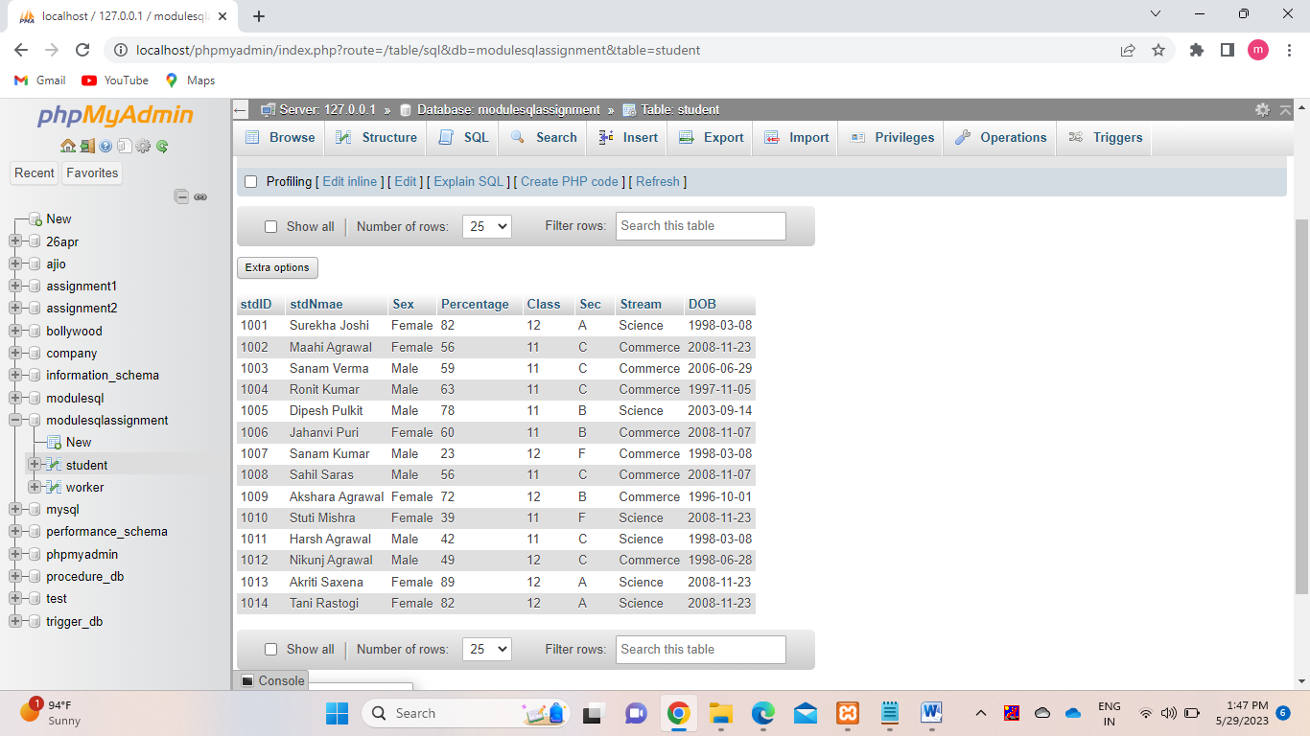

2) To display any name and date of birth from the table STUDENT. SELECT StdName, DOB FROM student ;

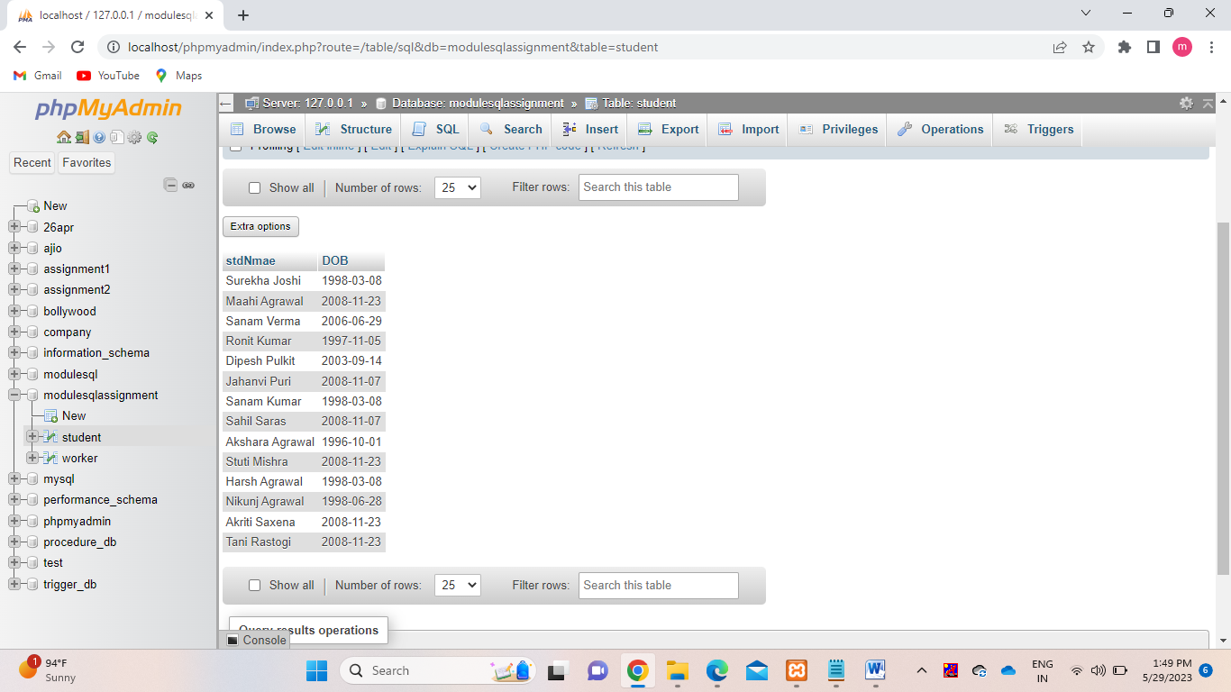

3) To display all students record where percentage is greater of equal to 80 FROM student table. SELECT * FROM student WHERE percentage >= 80;

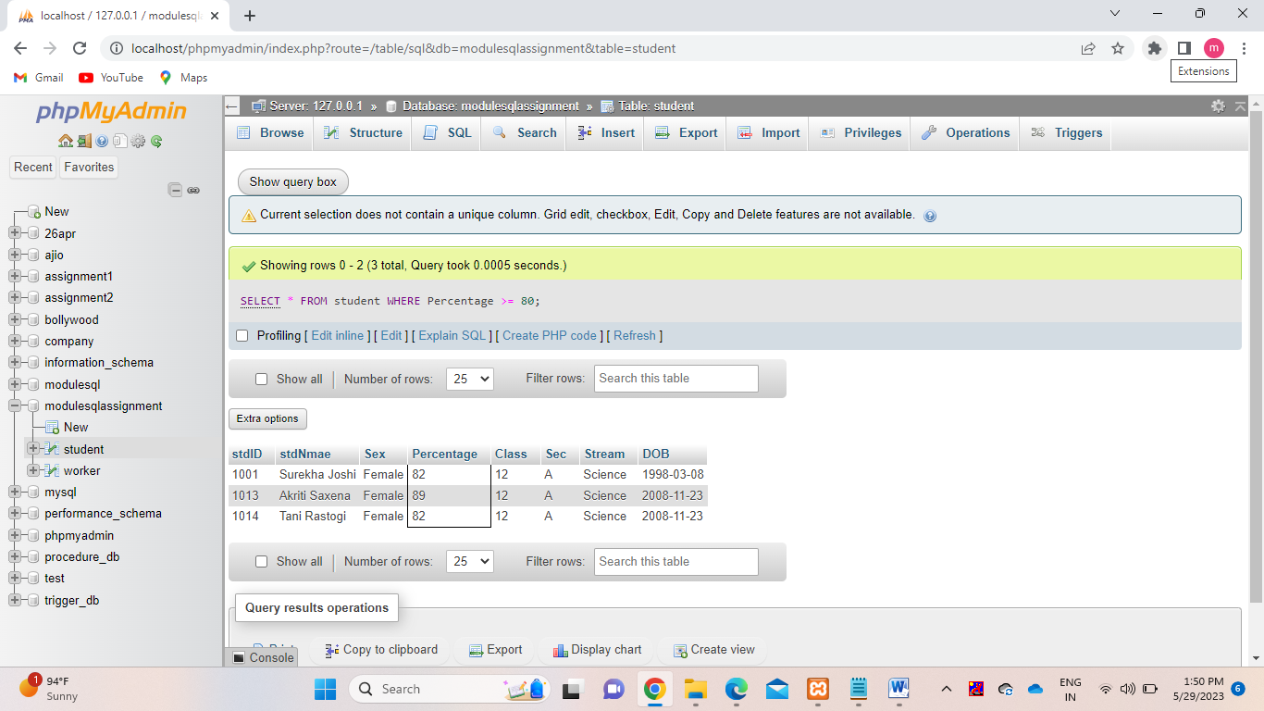

4) To display student name, stream and percentage where percentage of student is more than 80 SELECT StdName, Stream, Percentage WHERE percentage > 80;

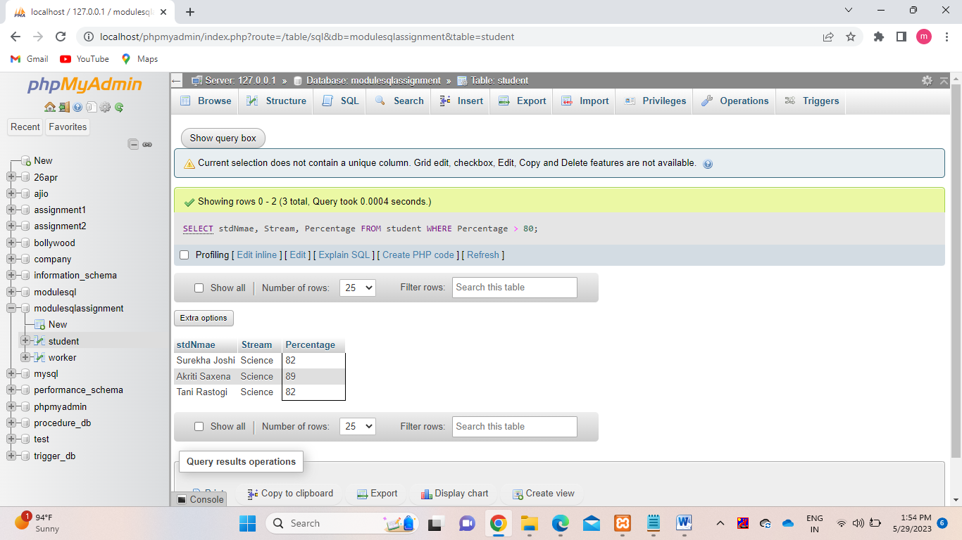

5) To display all records of science students whose percentage is more than 75 form student table. SELECT * FORM student WHERE stream = ‘Science’ AND percentage > 75;

